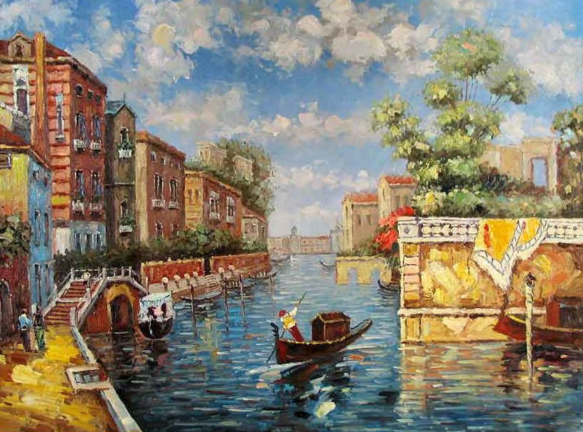There is a boat. There is water. There is stairs. There is a paddle. There is a man in a hat. There is a red building. There is a brown building. There is a building in the background. There is a tree. There is a bush. The water is very blue. The water has cyan blue, teal, arctic blue, sapphire blue, denim blue, spruce blue, peacock blue. The man is small. The shirt he is wearing is yellow. He is wearing a white shirt underneath. The water is reflective. The boat is larger than the man. The man is in the boat. There is a maroon boat. There is a dark brown boat. There are many squares and rectangular shapes on the walls. The stairs are by a ferry boat. The ferry boat is white with a black bottom. There are two people in the ferry. There is a yellow and white carpet and/or blanket draped over the railing on the right side.The path up the stairs is yellow, dark orange, light orange, and light brown. The windows are white. The windows have green plants and flowers on their cills. There is a brown and gray poll by the boat to the right. There is no dogs. There are no spaceships. There are no dragons. The sun is not showing. The man is wearing brown pants. His hat might be made of straw. The clouds are mixed with the color of white. The clouds are mixed with the color of black. The mixtures of colors in the sky make the clouds appear grey. This is a big place. There is a lot of space in this picture. The boat looks like it has a small barn like structure on it. There is no fire in the picture. There are no sharks in the water. One of the people on the side is wearing a blue shirt. Also that person is wearing dark grey pants. The person in blue is facing another person in front of them. That person is wearing a grey top. They are also wearing green and blue bottoms. There is a red and pink building that is very tall on the left. Next to the red building there id is a smaller dark grey building with two visible windows. Next to that building there is a slightly shorter building that is wider, has a slightly orange roof, and is a light shade of brown. It also has eight visible windows. Next to that building there is a small grey building with two visible windows. There is some grey smoke coming out of that building. There are no large monsters. There are no visible animals. There are no open lit fires. It appears to be daytime. The sun is not showing. The moon is not showing. There are two men and what appears to be one woman. Godzilla is not in the picture. There are no skyscrapers in the picture. There are no giant bugs in this picture.

